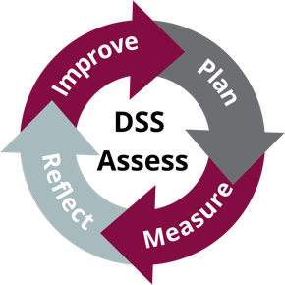
DSS Assess
June 20, 2022
Room 302 Corbett Center Student Union

1 | Introductions, again! | Melody
2 | Measures | Sarah
3 | DSS Assess feedback: Curriculum map and reporting  - Posting on Crimson Connection  - Work through curriculum map example | Sarah + Melody
4 | Meeting times, agenda items | Melody

